NDG NetLab+
Security+ V4 Lab Series
Lab_18: Wireless Networking Attack and
Mitigation Techniques

Lab Instruction -- READ CAREFULLY!
- You are required to perform all the steps in the Lab
- Take screenshots of the requested steps.
- All screenshots must be FULL, DETAILED and ANNOTATED.
- You MUST submit the Lab Report file (Word Processor) with EVERY requested screenshot NUMBERED in order
- To get full credit, each of your FULL screenshots MUST display and annotate your Reservation Number, Lab Title, and Date/Time of lab performance. See the example shown in the lab instructions sample file
- Failure to strictly follow ALL instructions will result in a 70% reduction in points.

---------------------------------------------------------------------------------------------------------------------------------------------
- Ensure that your lab exercise is done in the correct class portal –
- Lab exercise done on other old class portal will not be graded.
- Highlight your reservation number, lab title, and date /time of lab performance.

Following the example shown in the lab instruction sample, provide screenshots for the following steps. Your screenshot for every required step MUST be as displayed in the NDG lab instruction content manual

- Examining Plain Text Traffic

1.1 Viewing Plain Text Wireless Traffic

Step 8: 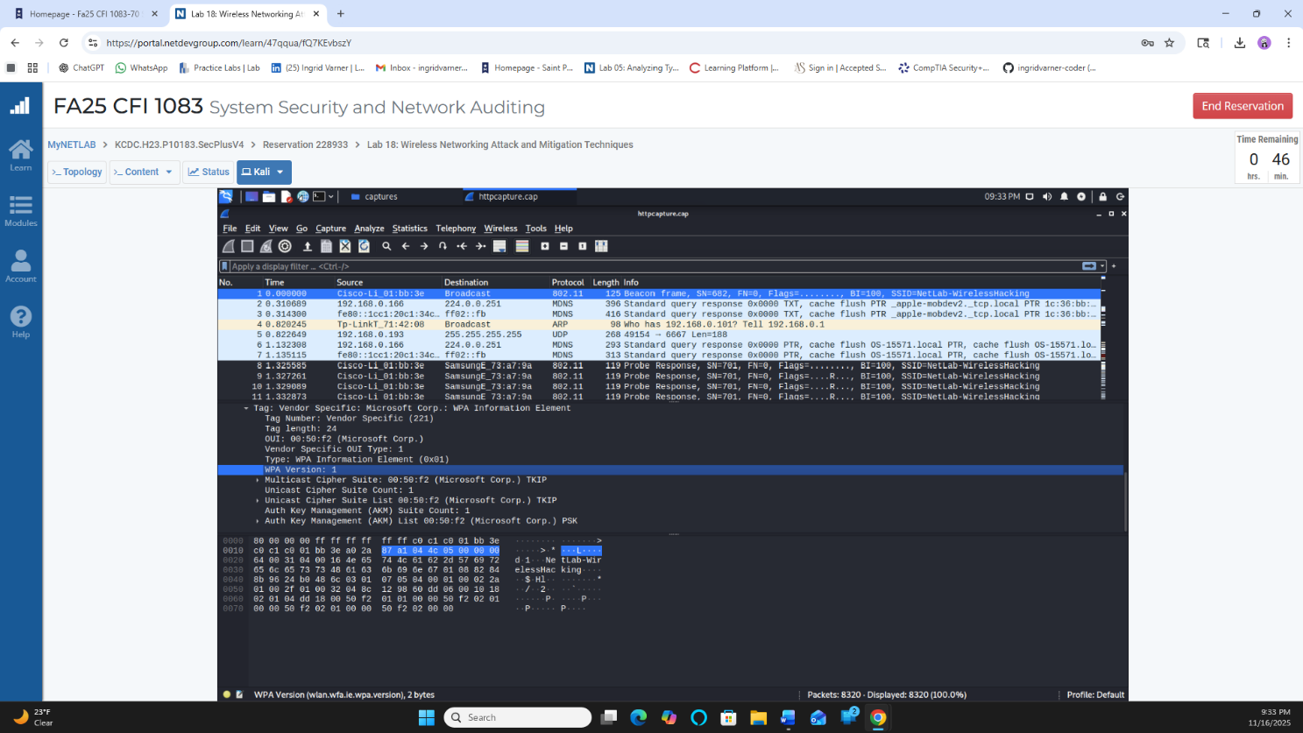

    - Extract Image from Capture

Step 4: 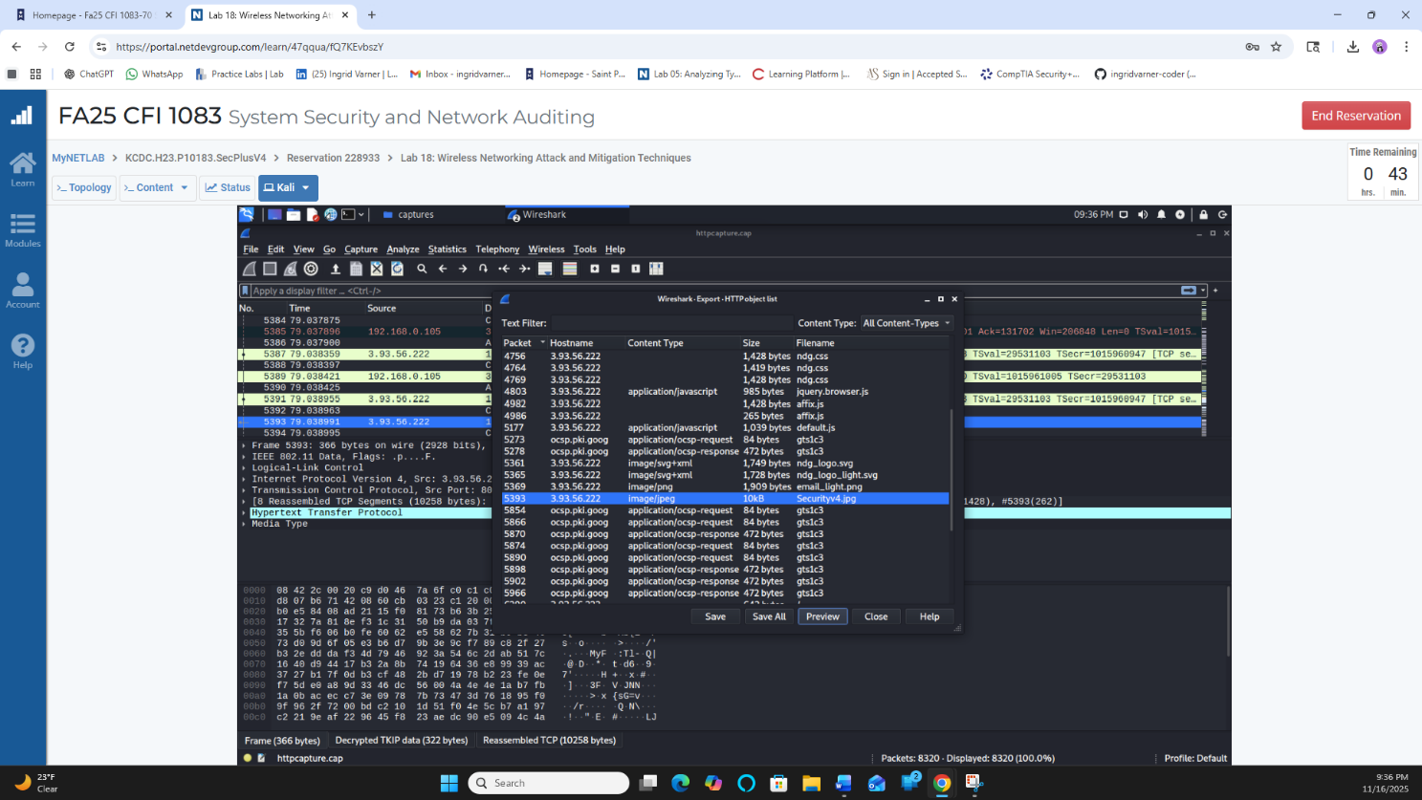
1.1.2 Extract Zip File from FTP Traffic
Step 1: 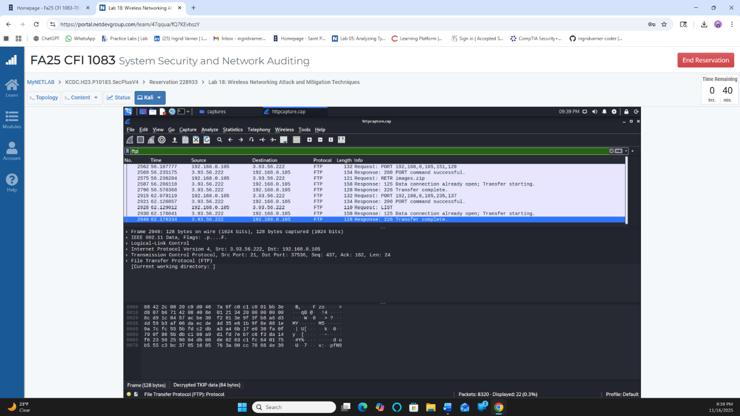

Step 4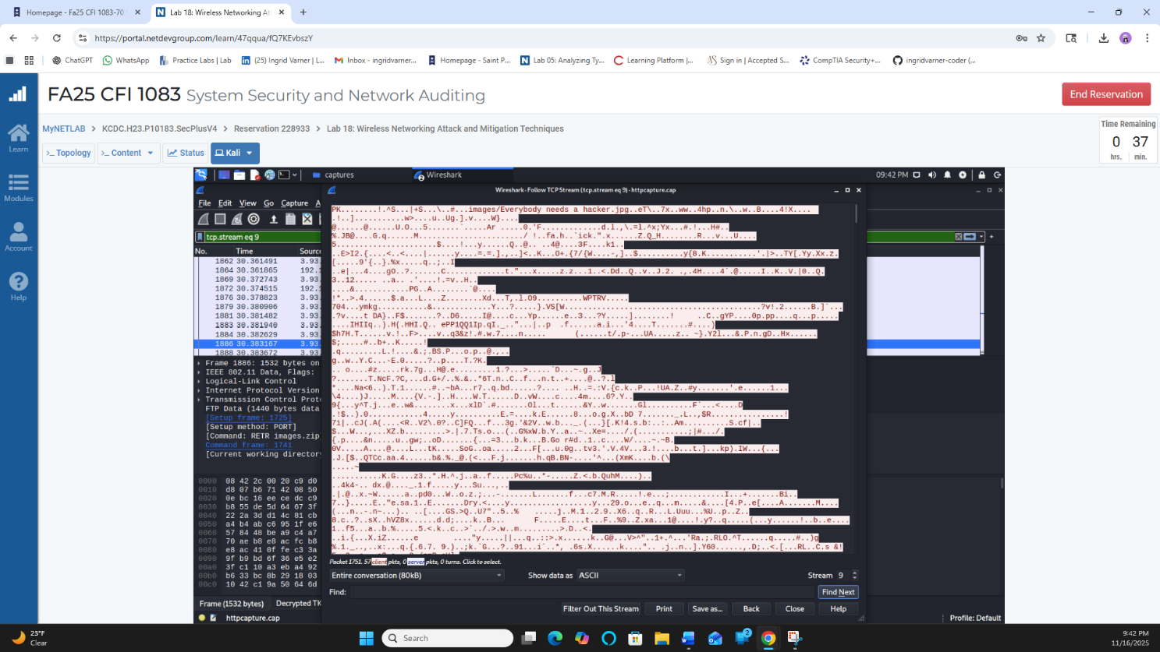

Step 10: 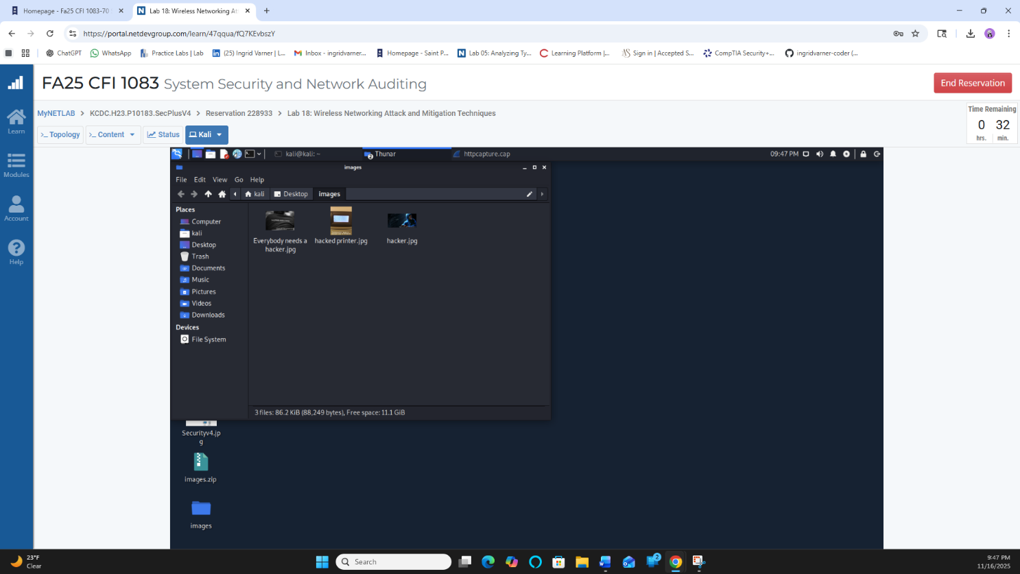
2 Exploiting and Examining WEP Traffic
2.1 Decrypt and Analyze WEP Traffic

Step 7: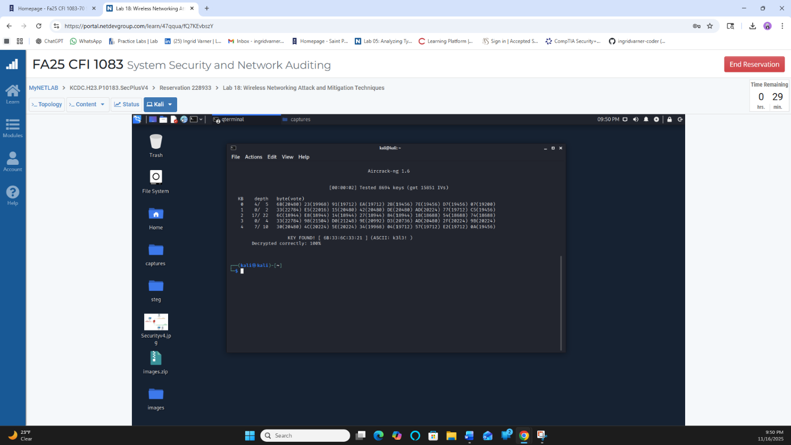

Step 10: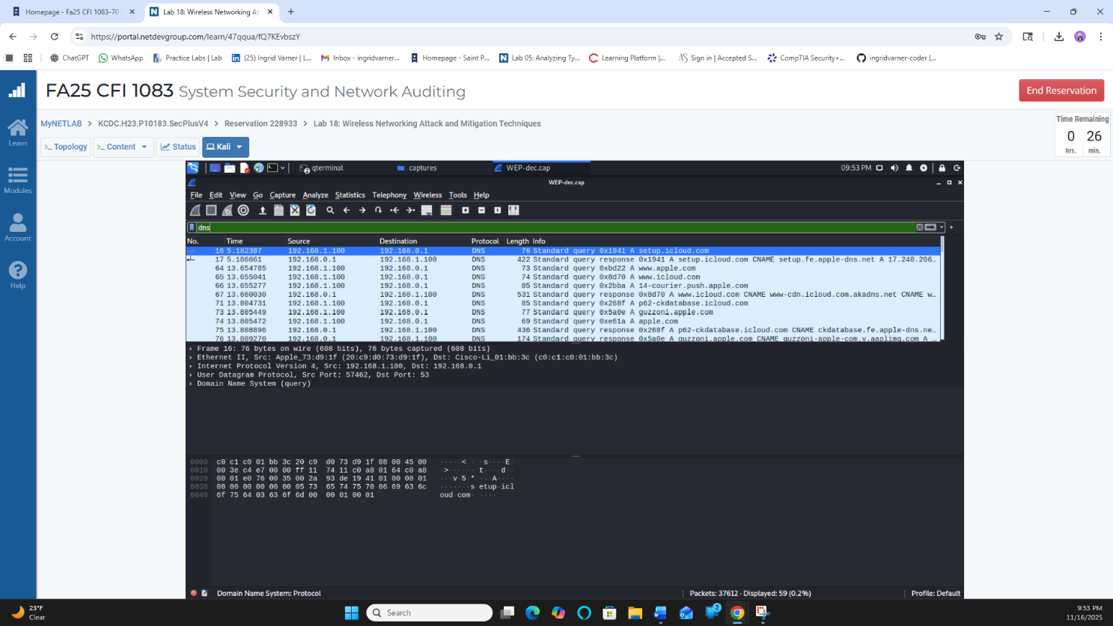

Step 13: 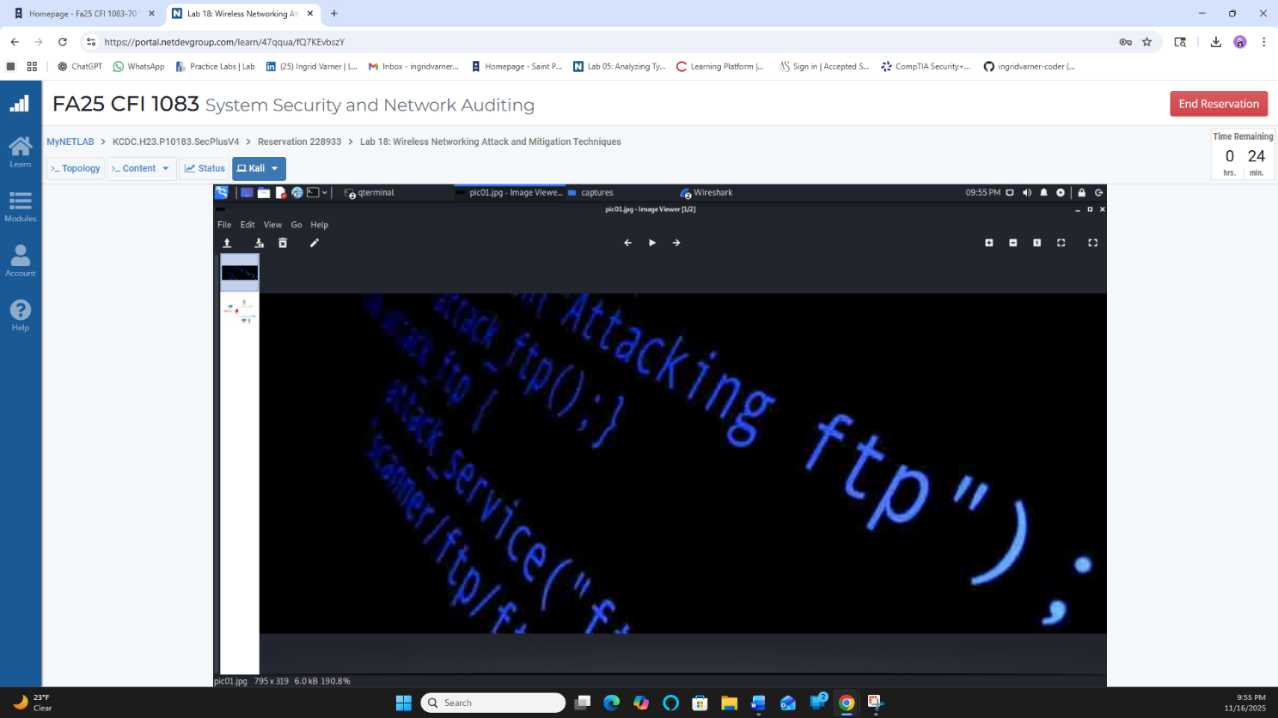

3 Exploiting and Examining WPA Traffic
3.1 Exploiting and Examining WPA Traffic
Step 5: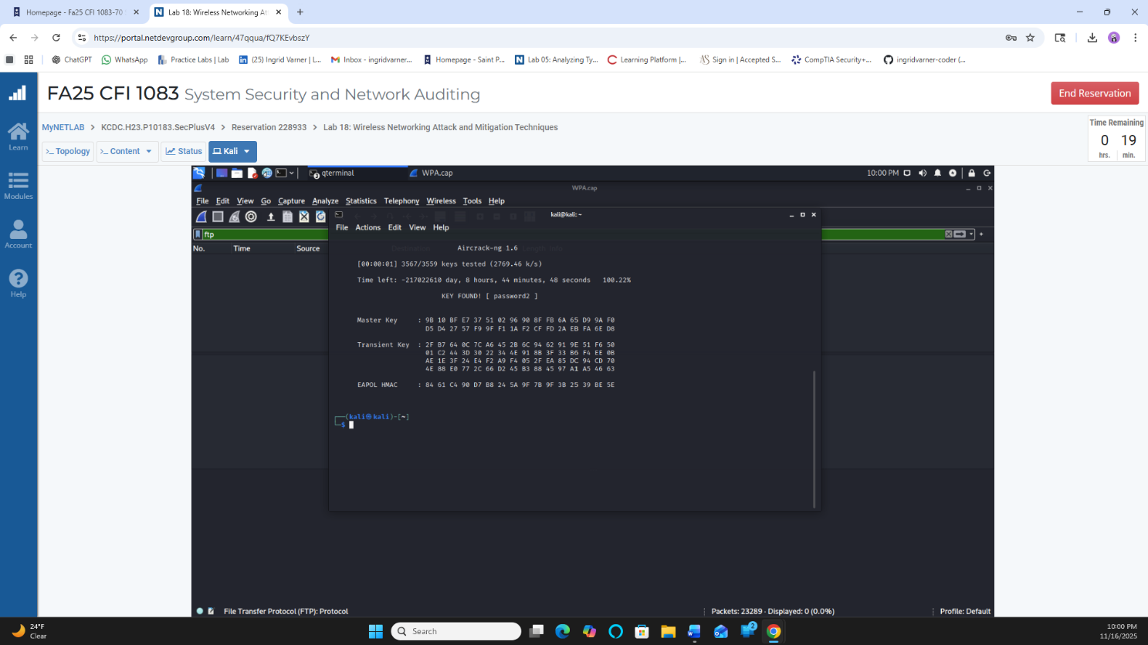

Step 12: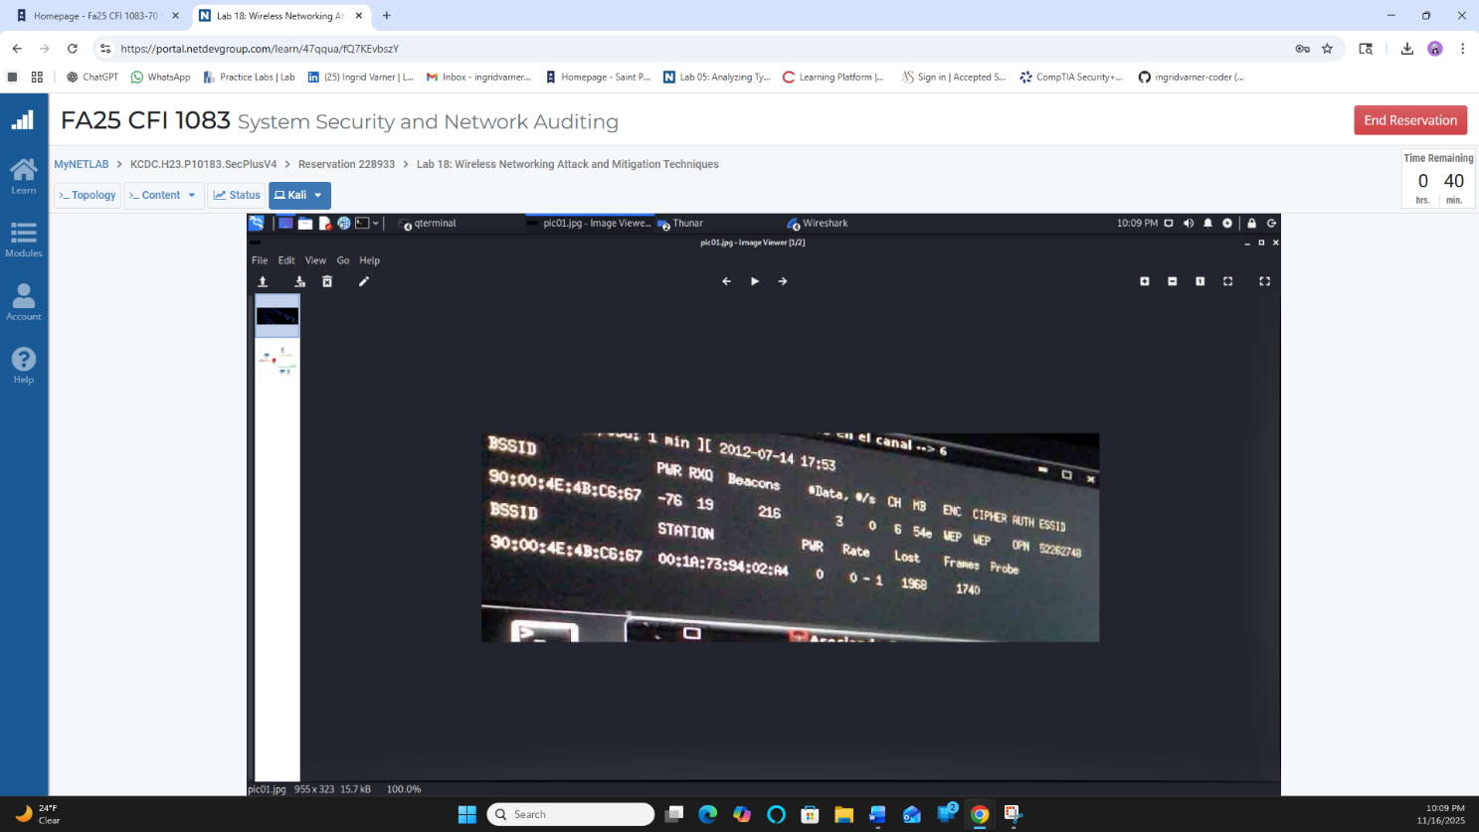

Step 18: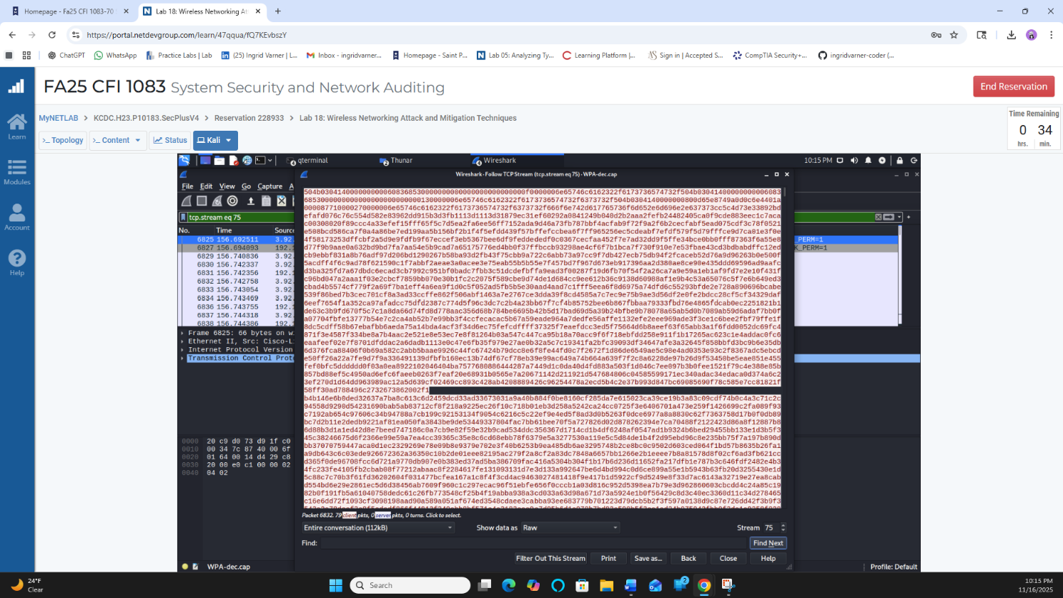

Lab Summary:
What did you accomplish in this lab assignment. Summarize your response in 2 paragraphs.
In this lab, I learned how wireless traffic can be captured and viewed using Wireshark and other tools. I was able to pull out pictures, ZIP files, and even usernames and passwords from the network traffic. I also practiced cracking WEP and WPA keys so I could decrypt the wireless data and see what people were sending. It was interesting to see how much information can be exposed when a network is not protected well.
I also had a lot of struggles during this lab, and I feel like that taught me even more. Some commands didn’t work for me at first, I kept getting “permission denied,” and I typed the fork bomb wrong many times before it finally worked. I also kept using the wrong virtual machine and had to redo things. Even though it was frustrating, it helped me learn how careful I need to be with commands and how small mistakes can break everything. In the end, I did finish it, and I understand wireless attacks much better now.

